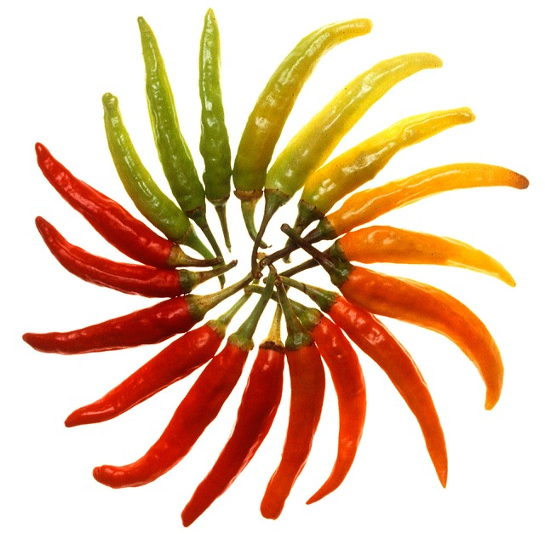
AT THE SORO
FALL FESTIVAL ON
OCTOBER 27th 2PM
NAME:
PHONE#/EMAIL:
NAME OF RECIPE:
X IF IT APPLIES TO YOUR CHILI
VEGETARIAN | NUT FREE | GLUTEN FREE
LEVEL OF SPICE: MILD 1 2 3 4 5FIRE HOT
ALL CHILI ENTRIES TO BE MADE OFF SITE AND DELIVERED IN A CROCK-POT TO THE SOUTH ROYALTON GREEN BY 2:00PM.
THE ROYALTON FIRE DEPARTMENT WILL SHARE ALL SUBMISSIONS WITH THE COMMUNITY. THE PRIZE WILL BE A PEOPLES CHOICE AWARD GIVEN OUT TO THE BEST CHILI CROCK- POT...PLUS A YEAR OF BRAGGING FOR THE BEST CHILI IN TOWN!
ALL ENTRIES TO BE MAILED AND RECEIVED NO LATER THAN OCTOBER 25th (SPACE IS LIMITED) TO:
KERRI ROGERS- P.O. BOX 871 S. ROYALTON VT 05068
ANY QUESTIONS CONTACT KERRI AT: klrogers1475@yahoo.com

